SIMATS ENGINEERING (SAVEETHA SCHOOL OF ENGINEERING)
Department of Computer Science and Engineering
ASSESSMENT TOOL 3 – Transformer Mechanics Worksheet

Course Code: | CSA6502 | Course Title: | Generative AI and Large Scale Model
CO Assessed: | CO1-Imitation (BL3) | Assessment: | Assessment Tool 3– Transformer Mechanics Worksheet
Weightage: | 10% of CIA | Total Marks: | 20
CO1 Statement: | Explain the fundamentals of Artificial Intelligence, Generative AI, Foundation Models, Transformer architecture, tokenization, embeddings, and Large Language Models.
Student Name: | C. Anu Keerthana | Reg. No.: | 192472057
Section / Batch: | 2024/CSE-AI | Date: | 20-07-2026

Code of Conduct
I _S.Sirivally / 192472371_ (Name / Reg No) certify that this submission is my original work and that I have adhered to the guidelines specified for this assessment. I understand that any violation of academic integrity rules will result in disciplinary action.
Signature of the Student: __C. Anu Keerthana_

Instructions
- This assessment contains 4 set of questions.
- Each student assigned with one set of questions .
- Each question carries 5 marks. Total: 20 Marks.
- Ensure clarity, structure, and logical flow in diagrams.
- Duration: 20 Minutes.

Annexure A Transformer Mechanics Worksheet

Transformer Mechanics Worksheet— SETA

Question 1: Tokenization (5 marks)
The word "UNHAPPINESS" is uncommon enough that a sub-word tokenizer would likely split it into smaller pieces rather than keep it whole.
- Split "UNHAPPINESS" into 3 reasonable sub-word pieces (there's no single "correct" answer — justify your split).
Answer: UN + HAPPI + NESS. "UN-" is a common negation prefix, "HAPPI" is the root carrying the core meaning (an allomorph of "happy"), and "-NESS" is a common suffix that turns an adjective into a noun. Splitting along these morpheme boundaries keeps each piece meaningful and reusable across many other words (e.g., "UN-LOCK", "HAPPI-LY", "SAD-NESS").
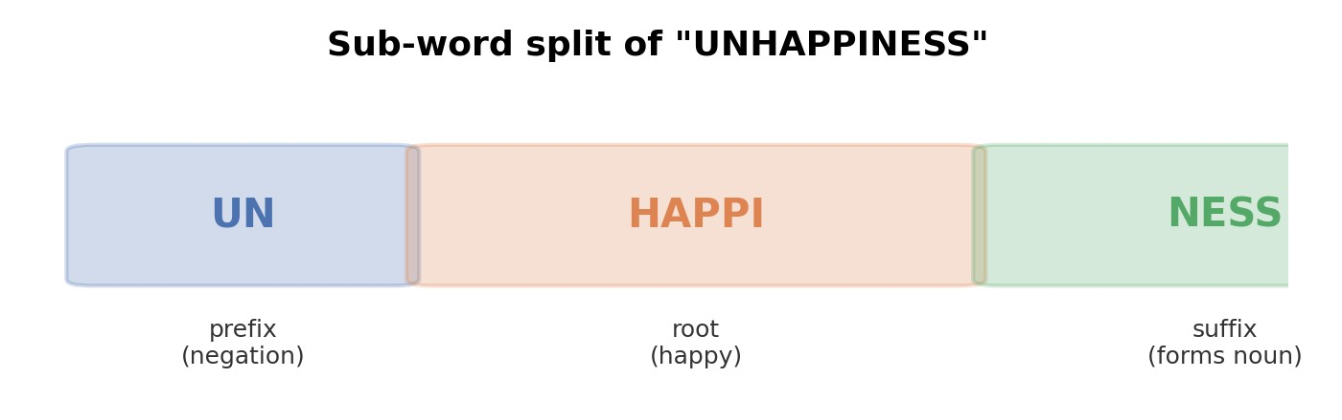
- In 1-2 sentences, explain WHY sub-word tokenization (rather than whole-word tokenization) helps a model handle a word like this one, even if the model has never seen the whole word before in training.
Answer: Because the pieces ("UN-", "HAPPI", "-NESS") appear frequently across many other words, the model has already learned useful representations for them individually, so it can compose a reasonable meaning for the unfamiliar whole word from familiar parts. Whole-word tokenization would instead treat any unseen word as a single unknown token, discarding all internal structure.

Question 2: Embeddings (5 marks)
Consider the word pairs "cat" and "kitten" and "cat" and "car".
- Which pair would you expect to have HIGHER cosine similarity in embedding space, and why?
Answer: "cat" and "kitten" would have higher cosine similarity. They are semantically related (a kitten is a young cat) and tend to appear in similar contexts, so a model trained on co-occurrence and meaning will place their vectors close together in direction. "cat" and "car" only share surface spelling, not meaning or usage, so their embeddings point in quite different directions despite looking alike as strings.
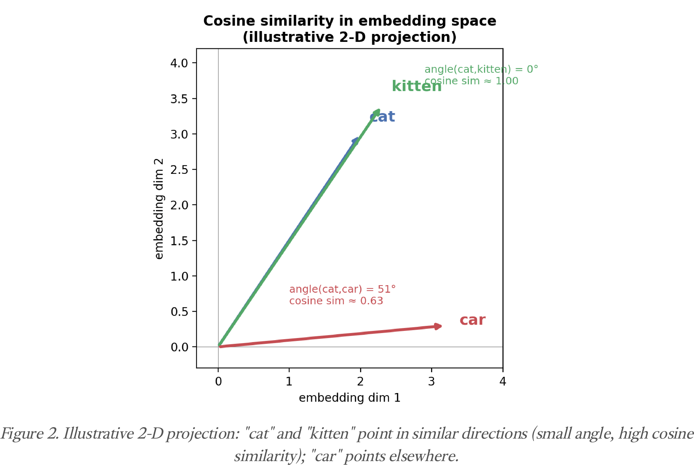
- In your own words, what does an embedding actually represent, and how is it different from a one-hot vector?
Answer: An embedding is a dense, learned vector of real numbers whose position in a high-dimensional space encodes a word's meaning and typical usage — words with similar meanings end up near each other. A one-hot vector, by contrast, is a sparse vector with a single 1 and all other entries 0; it only identifies which word it is, and every word is equally (and maximally) distant from every other word, with no notion of similarity built in.

Question 3: Self-Attention Worked Example (5 marks)
Read the sentence: "The trophy didn't fit in the suitcase because it was too big."
- The word "it" should attend most strongly to which other word in the sentence? Circle one:
"trophy" / "suitcase"
Answer:"trophy" — it is the trophy that is too big to fit, not the suitcase.
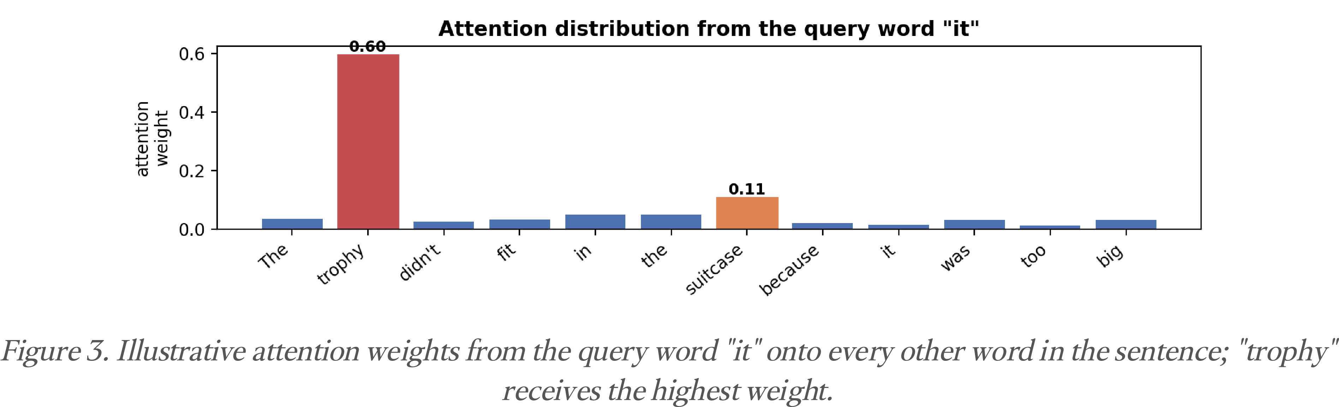
- Explain in 2-3 sentences WHY self-attention (not a simple word-order rule) is needed to correctly resolve what "it" refers to here.
Answer: Word order alone can't decide this: "it" is grammatically compatible with either "trophy" or "suitcase," and a fixed positional rule (like "always pick the nearest noun") would actually pick the wrong one ("suitcase") here. Self-attention instead lets the model weigh every word against "it" based on learned semantic and world-knowledge patterns, so it can recognize that "too big to fit" is a property that plausibly applies to the trophy rather than the suitcase, and assign the higher attention weight accordingly. If the sentence were changed to end in "...because it was too small," the correct referent would flip to "suitcase" — showing the resolution depends on meaning, not position.

Question 4: Query, Key, Value (5 marks)
In your own words, briefly explain what the Query, Key, and Value vectors each represent in self-attention, and how they combine to produce an attention score.
Answer: Every token produces three vectors from its embedding: a Query, representing what that token is "looking for" in the rest of the sentence; a Key, representing what that token "advertises" about itself so other tokens can find it; and a Value, representing the actual content that token will contribute if attended to. To compute attention, a token's Query vector is compared (via dot product) against every other token's Key vector — a high dot product means strong relevance. These raw scores are scaled and passed through softmax to become attention weights that sum to 1, and the token's output is then the weighted sum of all the Value vectors using those weights, so more relevant tokens contribute more to the result.

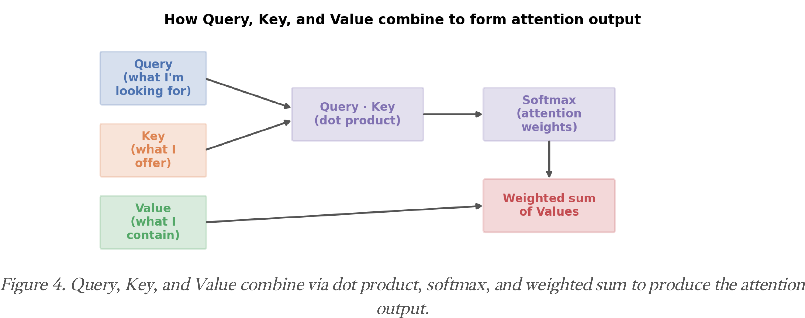

Rubrics for Calculation
Criteria | Wt. | Level 4 (Exemplary) | Level 3 (Proficient) | Level 2 (Developing) | Level 1 (Beginning)
Technical / Concept | 30% | Accurately explains tokenization, embeddings, and self-attention mechanics using correct terminology | Explains most mechanics correctly with minor gaps | Partial or superficial understanding of the mechanics | Major misunderstanding of core mechanics
Application | 25% | Correctly traces a worked example (e.g. computing attention relevance) step-by-step | Traces most steps correctly with minor errors | Significant errors when applying mechanics to the worked example | Cannot apply the mechanics to a worked example at all
Quality | 20% | Clear, logical, mathematically sound reasoning throughout | Mostly sound reasoning with minor errors | Reasoning has notable gaps or inconsistencies | Reasoning is disorganized or largely incorrect
Presentation | 15% | Neat, well-labeled diagrams/working, easy to follow | Reasonably clear presentation of working | Presentation is unclear in places | Difficult to follow presentation of working
Documentation / Communication | 10% | Shows all work with clear justification for every step | Shows most work with adequate justification | Minimal work shown | No work shown — answers only, unjustified

